Compass Surveys Back-End Architecture

# Technologies to Use

* .NET Core Web API for the API hosted in Azure
* SQL Server for the database
* Azure DevOps for CI/CD

# API Design

* The API will contain the following endpoints:

## Get all surveys

**GET** /survey

Request parameters: none

Response:

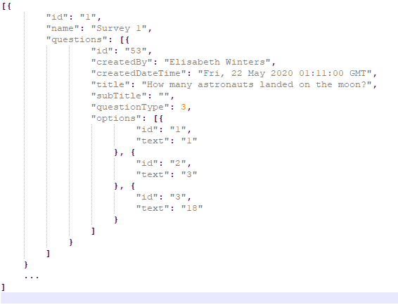

## Get survey by ID

**GET** /survey/:id

Request parameters:

:id – survey ID (string)

Response:

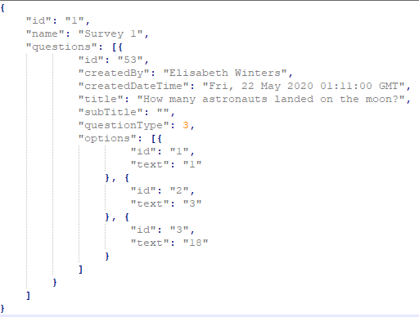

## Submit a survey response

**POST** /surveyresponse

Request body:

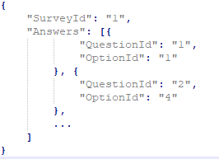

Response:



# SQL Design

Database schema is as follows:

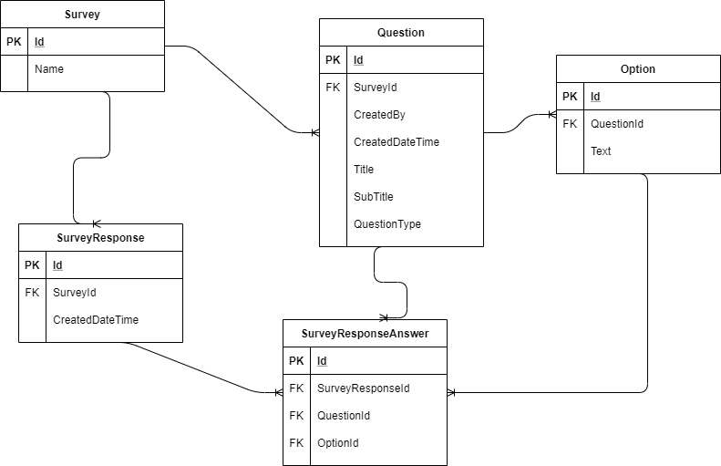

# Directory Structure

**CompassSurveys.BackEnd.Api**

* Controllers
* Models
* Interfaces

**CompassSurveys.BackEnd.Services**

* SurveyService
* Models
* Interfaces

**CompassSurveys.BackEnd.Repository**

* SurveyRepository
* Entities
* Interfaces

# Tests Design

Unit tests projects in solution:

* **CompassSurveys.BackEnd.Api.Tests**
* **CompassSurveys.BackEnd.Services.Tests**

Technologies/Frameworks:

* xUnit
* Moq
* FluentAssertions